Planetary Interaction Producing P4

High Sec has different rules than Lower Sec. One of them is how to do PI.

In Lower Sec Space one extracts P0 from the Planet (Aqueous Liquids) and sends it through Factories to produce P1 (Water). Possible production of P2 o rP3 can also take place. This is considered passive, and involves minimal time to manage. Minimal time is minimal Isk. In High Sec planets are less productive at P0, and the math implies to make P3 or P4.

P4 is a great deal more time, and riskier. There is Price Risk, that is the risk from buying from the market and selling in the market. There is Tax Risk, that is the prices one pays to import and export through the Customs Office. There is Combat Risk, that is pirates / players / Trigs potentially disrupting your Industrial Ships flight path. Increased risk is increased profits, and there is a reward worthy of the committed.

Increasing Risk & Time is Rewarding for those that opt-in.

If you choose to try to make P4, it would be wise to upgrade BPO's that utilize what you plan to make for the goal of producing out sized profits. Standup, Station, Mobile, and Structure are the key words to search out for the potential to make those big profits.

EVE Industry - Blueprint Calculator (eve-industry.org) is an excellent BPO price estimator. They should overestimates taxes, and assumes all materials are bought and sold at Jita. EVE-Cost - Manufacturing Calculator may be better. Often the price is lowest at Jita for raw materials compared to other Trade Hubs. P1 is cheap, P4 is not. Use BPO's to consume P4 to Produce Finished Goods, and sell it at other Trade Hubs for a great deal more. P1 bought at Jita used to produce modules sold outside of Jita can generate large profits. Evepraisal - Price check is the selling price estimator I use to pick which Trade Hub gets which goods to sell.

The potential for a 24 hour period to import P1 and produce P4 is about 10 units of P4. You can do the math to see if a BPO is too much time to produce the P4 for the potential profit. Mobiles use the least amount of raw materials. One can always sell the P4 at market, and it can be profitable enough to minimize the time sink at making Isk.

Stay safe, and Print that Isk!!

Initial Construction

To properly set up a P4 planet there are only 2 Planet Type Options - Barren or Temperate. Ideally a pilot should look for 6 Planets in the same system, or close together, for the two planet types that can make P4. Take note of the Tax Rates by inspecting the Customs Office in orbit. Factors to consider are the distance from the nearest Trade Hub, and Safety. The P1, Raw Materials, will need to be delivered to a station close by from a Trade Hub, and time is Isk.

Every planet needs a fully Upgraded Command Center, Launch Pad, 2x Warehouses. A pilot sets up 2 Warehouses to reduce problems with depositing the P1 and storing the P2-P4 until a pilot is able to transport Finished Goods off planet. Pilots can deliver more often than they can pick up. A Warehouse stores 12,000 m^3, and the Launchpad can hold 10,000m^3. A pilot can deliver at most 10,000m^3 to a planet's warehouse within roughly a 16 hour cooldown timer. This is due to the 10,000m^3 limit in the Launchpad. Each tier reduces volume of products at every step in the manufacturing process. Exports are significantly smaller volume than a pilot delivers, and only occasional exports will need to happen due to the smaller volume.

A pilot needs set up Links between structures to facilitate movement of products between structures. Links are the transportation for the raw materials and finished goods to flow around an outpost. Distance of Links consumes Powergrid and CPU. It is best practices to keep everything close together. The basic outpost should appear something displayed below….

The Initial Set Up - A fully upgraded Command Center, 2 Warehouses, Launchpad

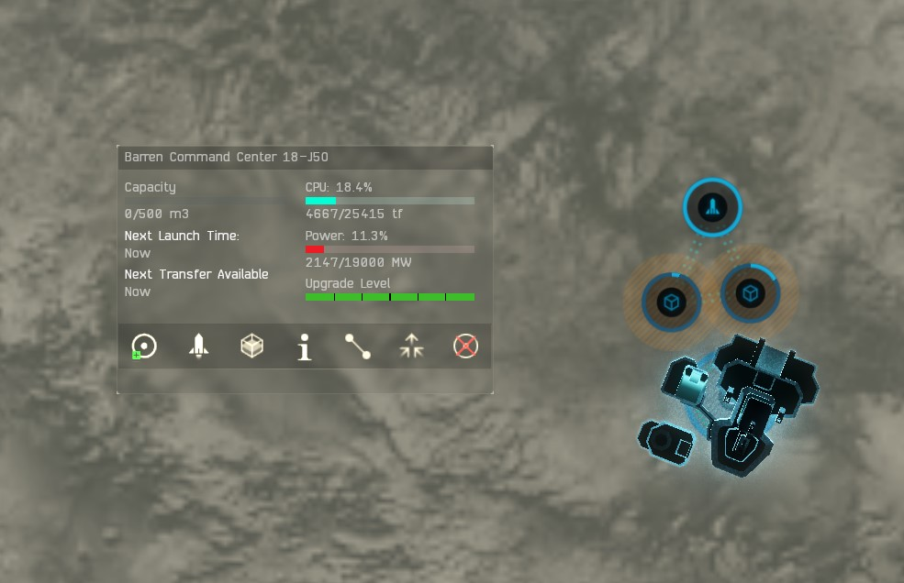

Initial Colonization P4 Production - Barren or Temperate

It is very easy to set up the P4 supply chain, but to get it done can take at least an hour. Once an outpost is set up, the only thing a pilots needs to do is move materials between the Launchpad, and Two Warehouses daily.

Place a High Tech Factory first. Then place the Advanced Factories to produce P3 required by the P4 factories. Set up Routes. Some P4 needs a bit of P1 in addition to P3.

Use Links to set up Routes between the Factories and Warehouses. Always set up routes between the Factories and Warehouses, never Factory to Factory. The Factories need a buffer, and the large space of a Warehouse supplies flexibility so that no resource is wasted with no time lost.

After setting up the P3 Advanced Factories, place the P2 Advanced Factories that produce raw materials needed for the P3 Advanced Factories. Link the P1 Raw Materials Warehouse to the P2 Advanced Factories after delivering an initial deposit of P1. Then Route the P2 Advanced Factories output to the (P2-P4) Warehouse. Have all P2-P3 Advanced Factories Route to a P3-P4 Warehouse.

Never route directly from a Factory to a Factory, Complications would cause resources to go wasted. Use a Raw Materials Warehouse to store the P1 and Route to the P2 Advanced Factories, and the P2 Finished Goods to the P2-P4 Warehouse. Use Links to set up Routes between the P4 High Tech Factories and P2-P4 Finished Goods Warehouse. This methodology minimizes the bottlenecks in the supply chain Maximizing efficiency is the goal of any manufacturer. The P2-P4 Warehouse can store variable amounts of the goods. Timing won't be so rigid a potential waste occurs, and factories production maximizes P4 with little time waste.

P4 & P3….

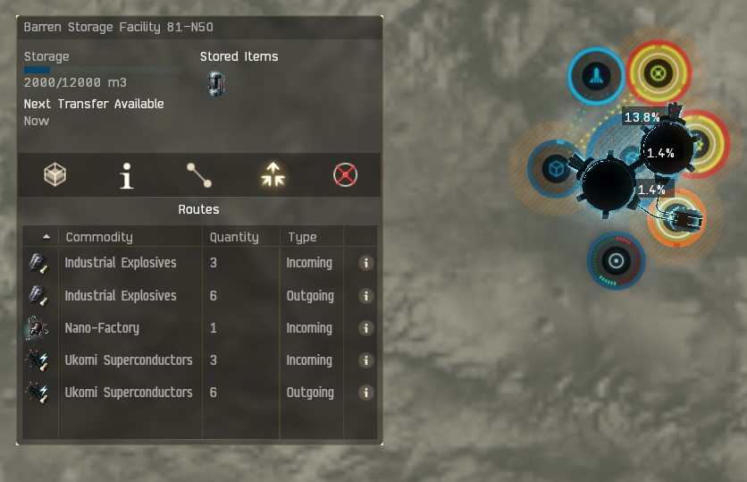

P4, P3, & P2….

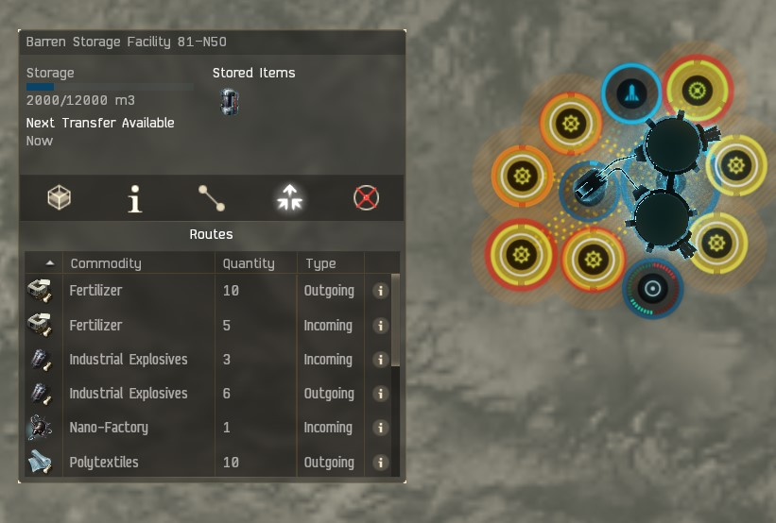

Advanced Factories roughly take Two Cycles (1 hour per cycle) of a lower tier Advanced Factory to produce outputs. If set up properly there will be 28-36 Factories by the time you have maximized the CPU and Power Grid to produce P4. It should take more P2 Advanced Factories than P3 Advanced Factories. Then more P3 Advanced Factories than P4 High Tech Factories. At a minimum it is ideal for 2 Advanced Factories producing each input to be producing for each 1 Finished Goods Output.

Some planets will produce more P4 than other planets since each P4 has variable inputs compared to other P4. Plan ahead at what P4 may produce only small amounts than the other P4 you choose to produce.

It will take over one day after a delivery of P1 to completely consume raw materials P2-P3 to produce the P4. A pilot should be delivering more P1 before the P4 has consumed all the P3. With two Warehouses there will be flexibility in the supply chain. The final outpost should look something like what is pictured below…

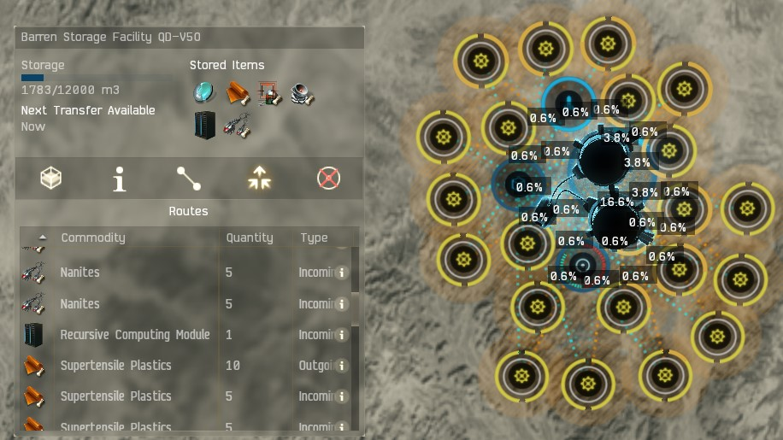

Mathematical Computations

You will need to add up the total P1 needed to deposit on outposts for the 1, 2, 3, 5 Day Amounts. The Player Owned Customs Office can fit 3 Days, and 1 Day will fit in the Warehouse. So one deposits 2 Days, move 1 Day over, then move the Second Day, then Deposit the Three Day amounts. That is a total of 5 Days. A pilot only needs to use an Industrial Ship to deposit P1 once every 5 Days.

26316 Units of P1 can fit in 10,000m^3. Some P4 needs a P1 combined with two types of P3 to produce. This number is 904 to roughly produce a day's P4. The math looks like below for 1 day of production P4…

Recursive Computing Module |  | 1 Day | 2 Days | 3 Days | 5 Days
Bacteria | 6 | 5262 | 10524 | 15786 | 26310
Biofuels | 2 | 1754 | 3508 | 5262 | 8770
Biomass | 3 | 2631 | 5262 | 7893 | 13155
Chiral Structures | 2 | 1754 | 3508 | 5262 | 8770
Oxygen | 3 | 2631 | 5262 | 7893 | 13155
Plasmoids | 2 | 1754 | 3508 | 5262 | 8770
Precious Metals | 2 | 1754 | 3508 | 5262 | 8770
Reactive Metals | 4 | 3508 | 7016 | 10524 | 17540
Water | 6 | 5262 | 10524 | 15786 | 26310
Total | 30
Per Factory | 877
Self Harmonizing Power Core
Biomass | 2 | 1878 | 3756 | 5634 | 9390
Electrolytes | 3 | 2817 | 5634 | 8451 | 14085
Industrial Fibers | 4 | 3756 | 7512 | 11268 | 18780
Oxidizing Compound | 4 | 3756 | 7512 | 11268 | 18780
Oxygen | 1 | 939 | 1878 | 2817 | 4695
Plasmoids | 3 | 2817 | 5634 | 8451 | 14085
Precious Metals | 2 | 1878 | 3756 | 5634 | 9390
Proteins | 2 | 1878 | 3756 | 5634 | 9390
Silicon | 4 | 3756 | 7512 | 11268 | 18780
Toxic Metals | 2 | 1878 | 3756 | 5634 | 9390
Water | 1 | 939 | 1878 | 2817 | 4695
Total | 28
Per Factory | 939

Nano Factory |  | 1 Day | 2 Days | 3 Days | 5 Days
Bacteria | 4 | 3176 | 6352 | 9528 | 15880
Biofuels | 4 | 3176 | 6352 | 9528 | 15880
Electroylytes | 4 | 3176 | 6352 | 9528 | 15880
Industrial Fibers | 4 | 3176 | 6352 | 9528 | 15880
Oxygen | 4 | 3176 | 6352 | 9528 | 15880
Plasmoids | 4 | 3176 | 6352 | 9528 | 15880
Proteins | 4 | 3176 | 6352 | 9528 | 15880
Reactive Metals | 904 | 904 | 1808 | 2712 | 4520
Water | 4 | 3176 | 6352 | 9528 | 15880
Total | 32
Per Factory | 794

Broadcast Node |  | 1 Day | 2 Days | 3 Days | 5 Days
Biofuel | 3 | 2817 | 5634 | 8451 | 14085
Biomass | 3 | 2817 | 5634 | 8451 | 14085
Chiral Structures | 3 | 2817 | 5634 | 8451 | 14085
Industrial Fibers | 6 | 5634 | 11268 | 16902 | 28170
Oxidizing Compound | 6 | 5634 | 11268 | 16902 | 28170
Oxygen | 3 | 2817 | 5634 | 8451 | 14085
Plasmoids | 3 | 2817 | 5634 | 8451 | 14085
Precious Metals | 3 | 2817 | 5634 | 8451 | 14085
Silicon | 6 | 5634 | 11268 | 16902 | 28170
Total | 36
Per Factory | 939

Steriel Conduit |  | 1 Day | 2 Days | 3 Days | 5 Days
Bacteria | 4 | 3176 | 6352 | 9528 | 15880
Biofuel | 4 | 3176 | 6352 | 9528 | 15880
Biomass | 4 | 3176 | 6352 | 9528 | 15880
Chiral Structure | 4 | 3176 | 6352 | 9528 | 15880
Protein | 4 | 3176 | 6352 | 9528 | 15880
Reactive Metal | 4 | 3176 | 6352 | 9528 | 15880
Silicon | 4 | 3176 | 6352 | 9528 | 15880
Toxic Metal | 4 | 3176 | 6352 | 9528 | 15880
Total | 32
Per Factory | 794
Wetware Mainframe |  | 1 Day | 2 Days | 3 Days | 5 Days
Bacteria | 6 | 4386 | 8772 | 13158 | 21930
Biofuels | 2 | 1462 | 2924 | 4386 | 7310
Chiral Structures | 2 | 1462 | 2924 | 4386 | 7310
Electrolytes | 4 | 2924 | 5848 | 8772 | 14620
Oxygen | 2 | 1462 | 2924 | 4386 | 7310
Proteins | 4 | 2924 | 5848 | 8772 | 14620
Reactive Metals | 6 | 4386 | 8772 | 13158 | 21930
Toxic Metals | 4 | 2924 | 5848 | 8772 | 14620
Water | 6 | 4386 | 8772 | 13158 | 21930
Total | 36
Per Factory | 731

Organic Mortar Applicatoes |  | 1 Day | 2 Days | 3 Days | 5 Days
Bacteria | 907 | 907 | 1814 | 2721 | 4535
Chiral Structures | 4 | 3176 | 6352 | 9528 | 15880
Electrolytes | 4 | 3176 | 6352 | 9528 | 15880
Oxidizing Compound | 4 | 3176 | 6352 | 9528 | 15880
Oxygen | 4 | 3176 | 6352 | 9528 | 15880
Precious Metals | 4 | 3176 | 6352 | 9528 | 15880
Reactive Metals | 4 | 3176 | 6352 | 9528 | 15880
Toxic Metals | 4 | 3176 | 6352 | 9528 | 15880
Water | 4 | 3176 | 6352 | 9528 | 15880
Total | 32
Per Factory | 794
Integrity Response Drones |  | 1 Day | 2 Days | 3 Days | 5 Days
Bacteria | 2 | 1462 | 2924 | 4386 | 7310
Biofuels | 4 | 2924 | 5848 | 8772 | 14620
Biomass | 4 | 2924 | 5848 | 8772 | 14620
Chiral Structures | 4 | 2924 | 5848 | 8772 | 14620
Industrial Fibers | 2 | 1462 | 2924 | 4386 | 7310
Oxidizing Compounds | 2 | 1462 | 2924 | 4386 | 7310
Oxygen | 4 | 2924 | 5848 | 8772 | 14620
Plasmoids | 4 | 2924 | 5848 | 8772 | 14620
Precious Metals | 4 | 2924 | 5848 | 8772 | 14620
Reactive Metals | 2 | 1462 | 2924 | 4386 | 7310
Silicon | 2 | 1462 | 2924 | 4386 | 7310
Water | 2 | 1462 | 2924 | 4386 | 7310
Total | 36
Per Factory | 731

P3

Some P3 is used to make Tech I Modules, and other P3 makes Tech II. The market for Tech I, and is preferable for those that plan to sell. To gauge what a P3 makes, choose the P3, and then check the industry tab after show info is clicked. Tech I modules are made in much larger quantities than Tech II. So to make certain there is a market that will buy from a pilot, P3 should be used in Tech I if maximizing sales is a consideration.

Tech I sourced P3

Ukomi Superconductors
Synthetic Synapses
Supercomputers
Smartfab Units
Nuclear Reactors
High-Tech Transmitter
Hermetic Membranes
Guidance Systems
Gel-Matrix Biopaste
Data Chips

